**Student Guide**

**Note: Please resize (using Microsoft Paint) the image to not more than 500kb (recommended 200kb or below) before uploading it for ALL submissions.**

**Else, the system will reject the image upload and display a message at the right-top corner of the computer screen:**

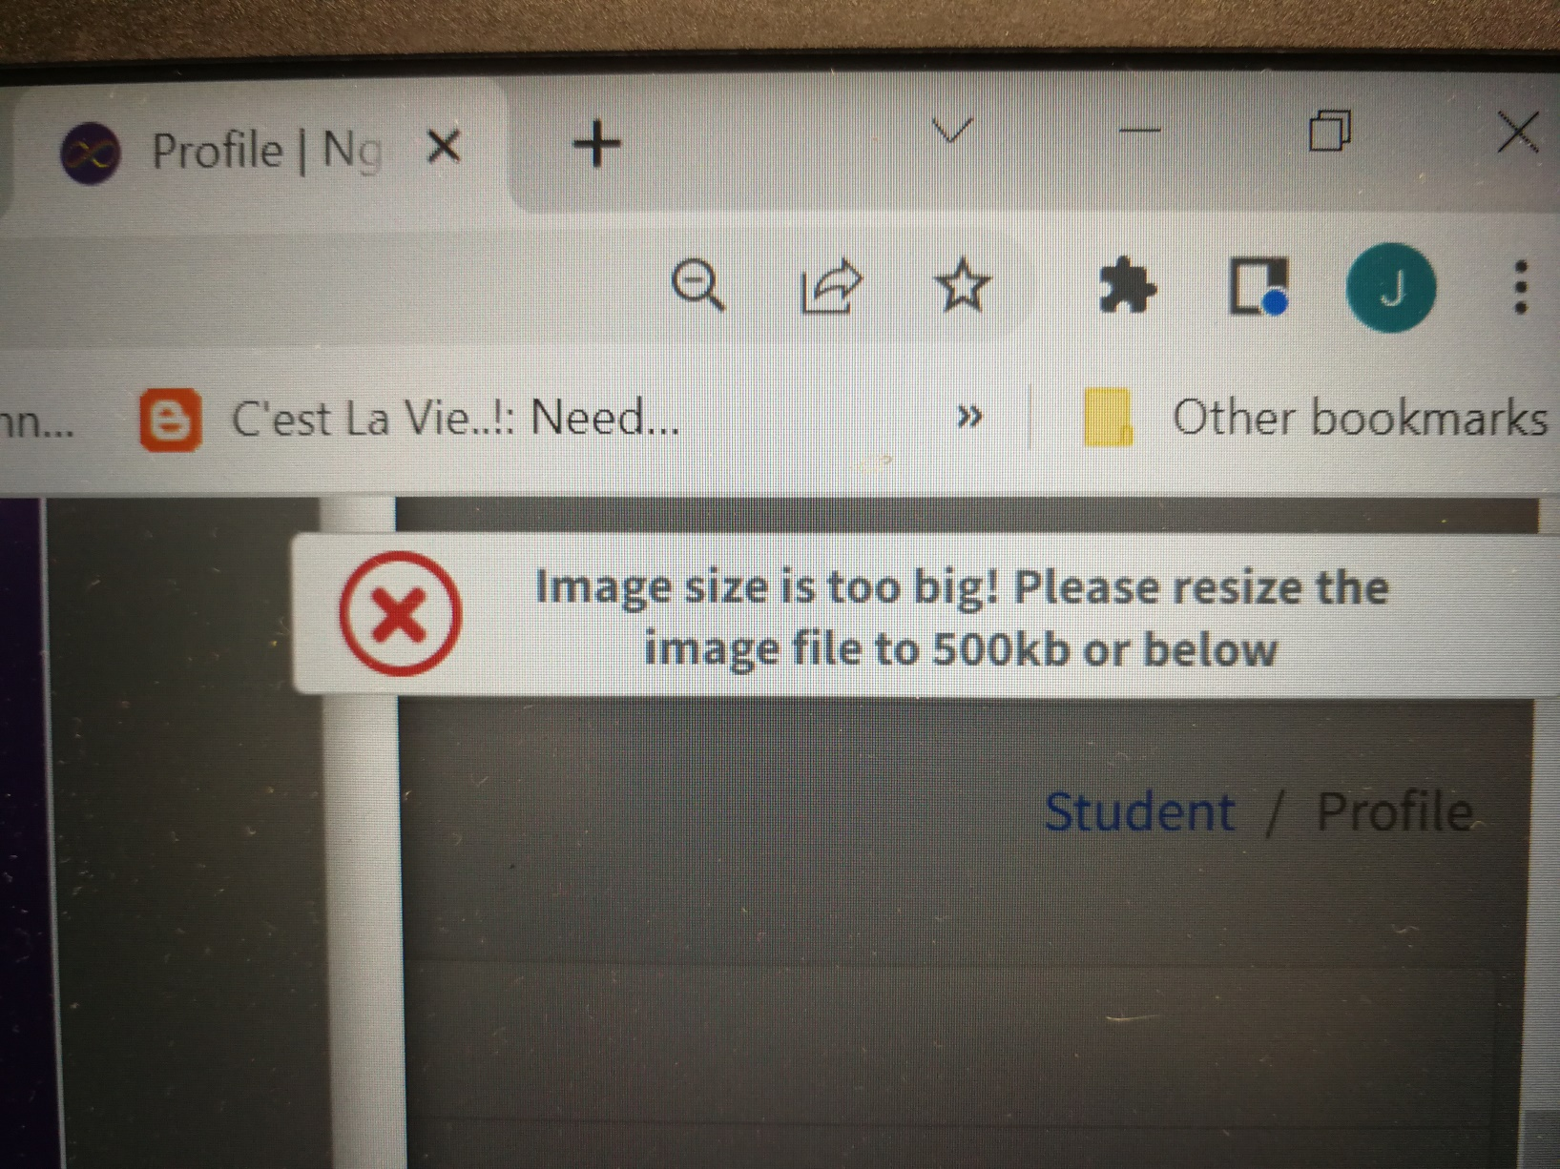

**Quick guide:**

|  |  |  |
| --- | --- | --- |
| **Item** | **Icons** | **Actions** |
| 1 |  | To **edit** a work (e.g. student profile, personal work, internship or team project) |
| 2 |  | To **delete** a work (e.g. student profile, personal work, internship or team project) |
| 3 |  | To **add** an new entry or team member |
| 4 |  | To **delete** current entry or team member |
| 5 |  | **Notation** |
| 6 |  | Image size **exceeds** **limit**. Advise the student to resize the image to not more than 200kb and upload it again |

1. **Login ID and Password**
2. First level authentication - please provide your **NPSTD ID** and **NPSTD Password** for both portal and cohort web sites (will be implemented from 5th week of the first semester)

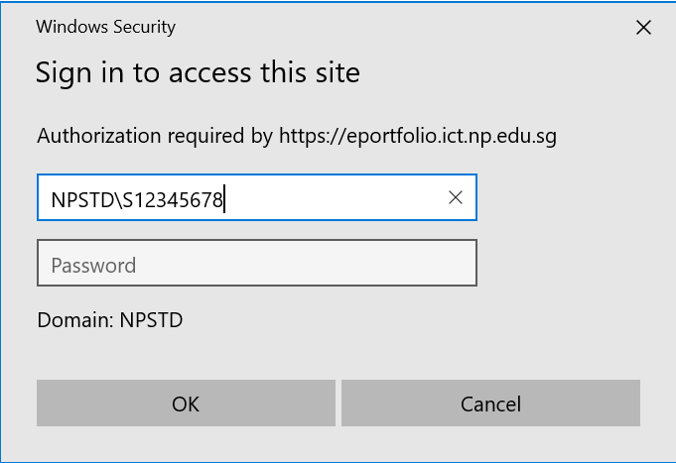

2. Second level authentication - ePortfolio portal: https://eportfolio.ict.np.edu.sg/portal/

* 1. Login ID: Please refer to your student card. Login ID is your student number on the card.
  2. The default password is “**password**” if you have yet to change the password
  3. Please change the password immediately
  4. Please refer to student guide on how to change password

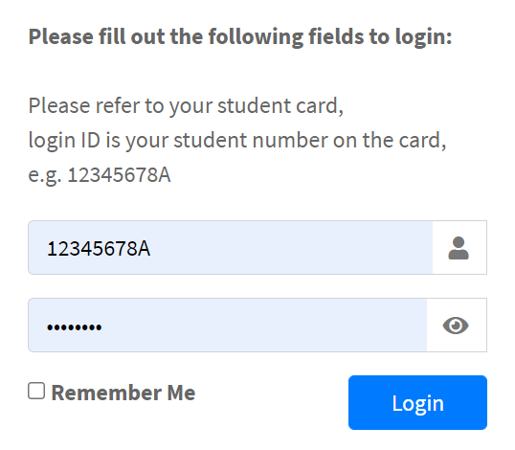

1. **How to exit from portal?** Click the arrow sign

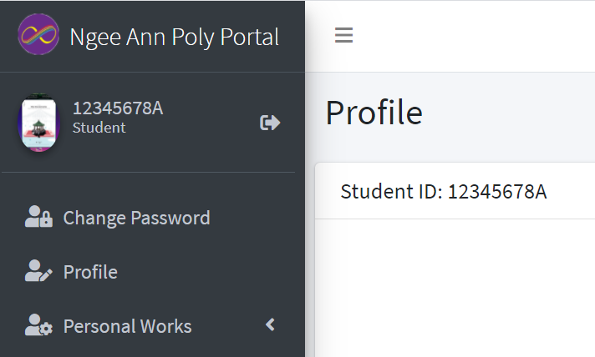

1. **How to change password?**
   1. Click “Change Password” from the left-hand-side panel



* 1. Enter the required fields, and ‘Save”

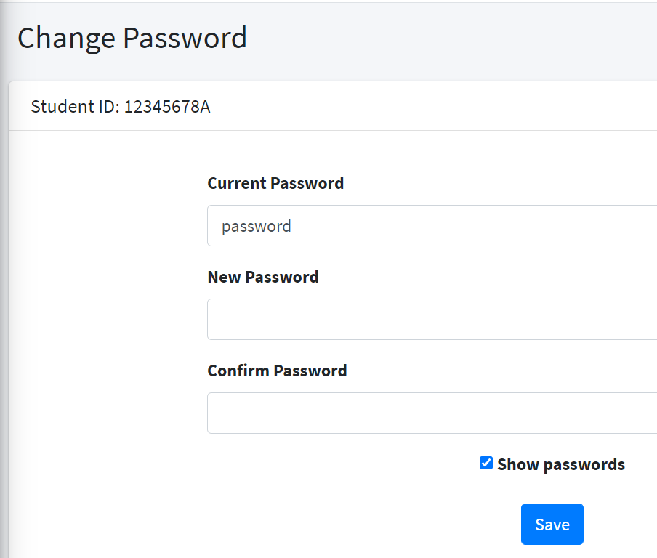

1. **How to create student profile?**
   1. Click “Profile” from the left-hand-side panel

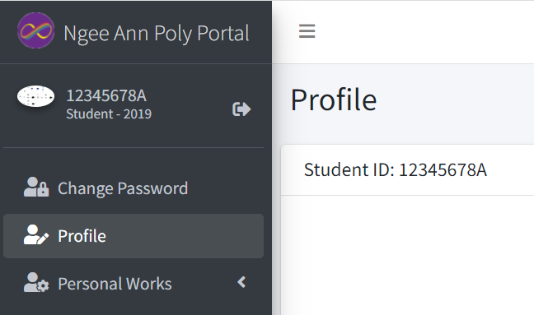

* 1. To add/change an image – click “Change Profile Picture”

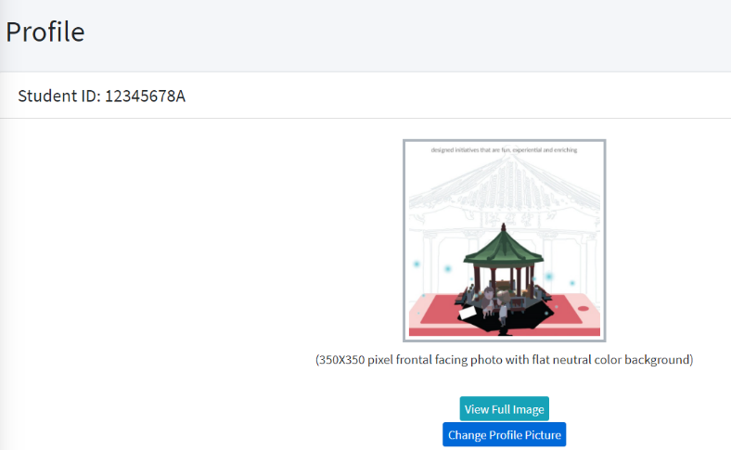

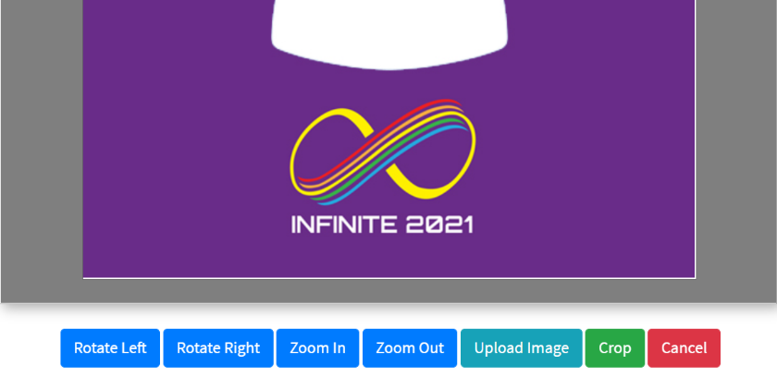

* 1. Use Microsoft Paint to **resize the image to 350x350 pixels before upload**
  2. You may zoom in/out, and **Click Crop to COMPLETE the upload process**
  3. A message will appeared. Click “Close”, and continue to update student profile

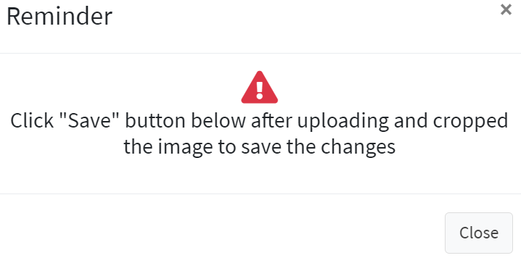

1. **Update profile**

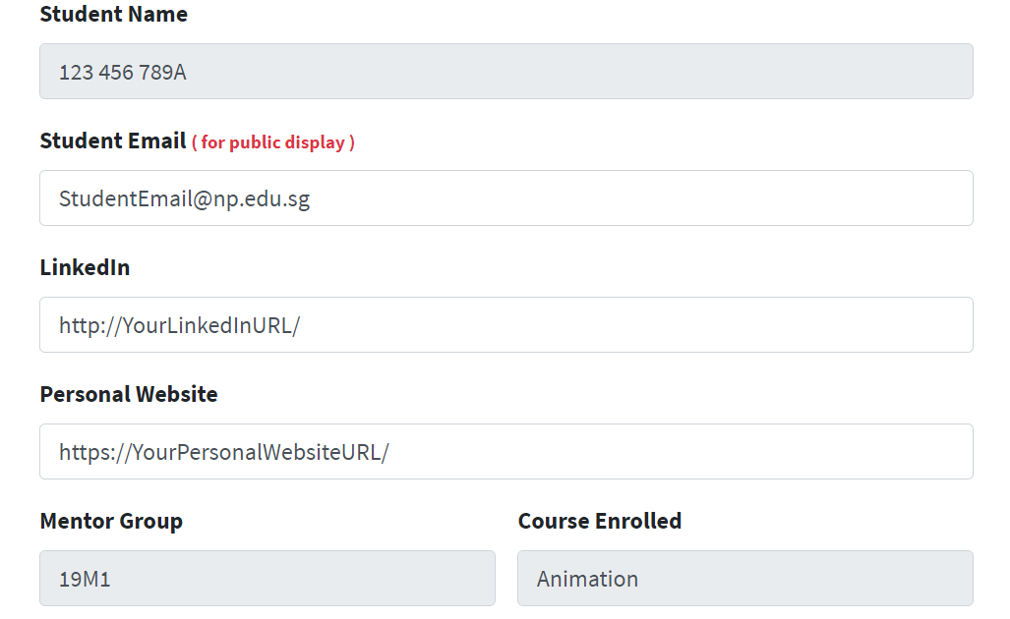

* 1. **Student Email (for public display): default is NP Connect Mail. However, you may change it to personal email**
  2. **LinkedIn:** Your LinkedIn website
  3. **Personal Website:** Your personal web site

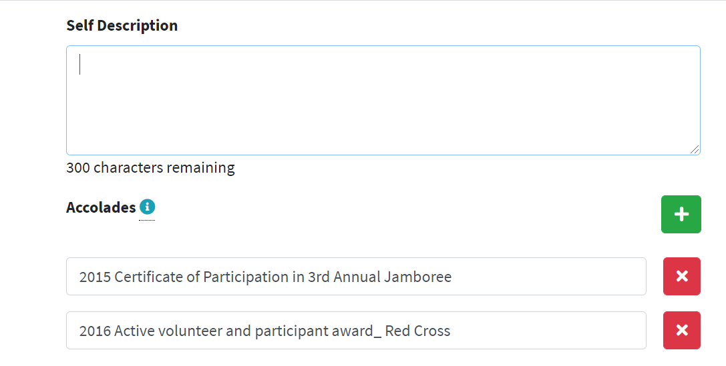

* 1. **Self Description:** Maximum 300 characters
  2. **Accolades:** Click “+”to add; “x” to delete

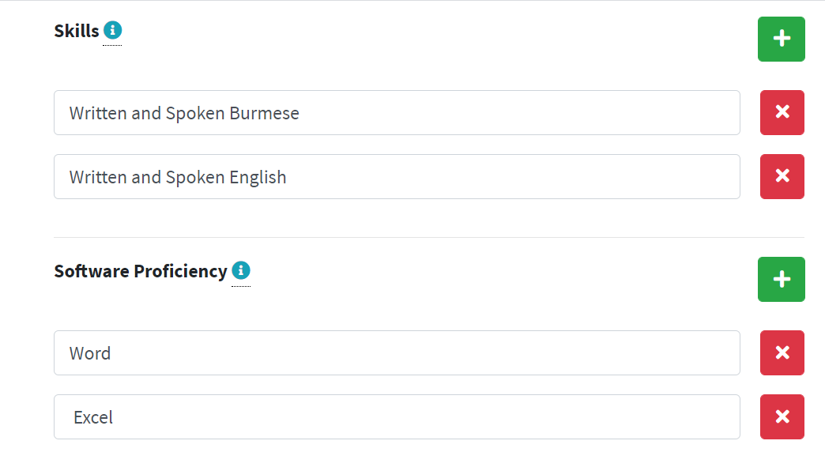

* 1. **Skills:** Click “+”to add; “x” to delete
  2. **Software Proficiency:** Click “+”to add; “x” to delete

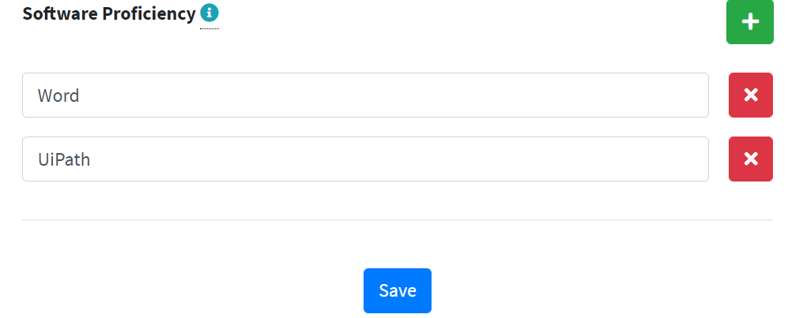

* 1. Click “Save” button to save

1. **How to create Personal Works?**

* 1. Click “Personal Works”->”List” from left-hand-side-panel

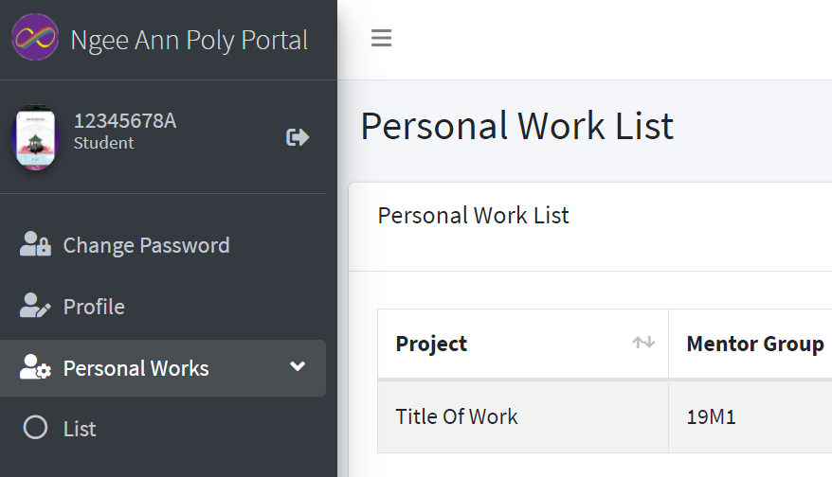

* 1. Add personal project

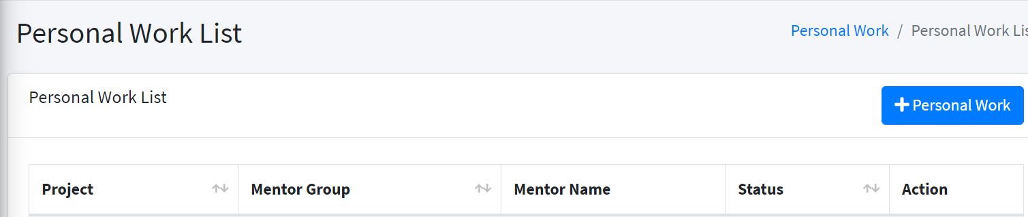

* 1. There are threetype of personal projects available
* **Personal work with one or more images** - Multiple images with project description, tools used and medium of art work
* **External** - Website with one mandatory image
* **YouTube** - YouTube with one mandatory image

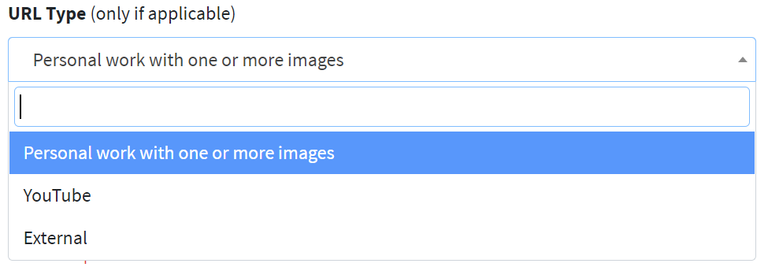

1. **Personal work with one or more images**

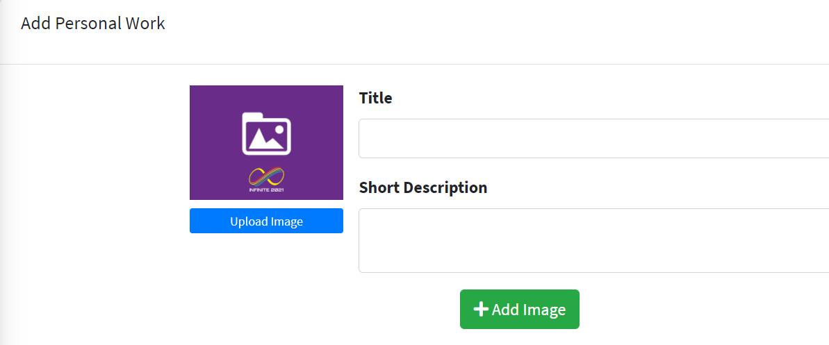

1. Click “Upload Image” to upload image

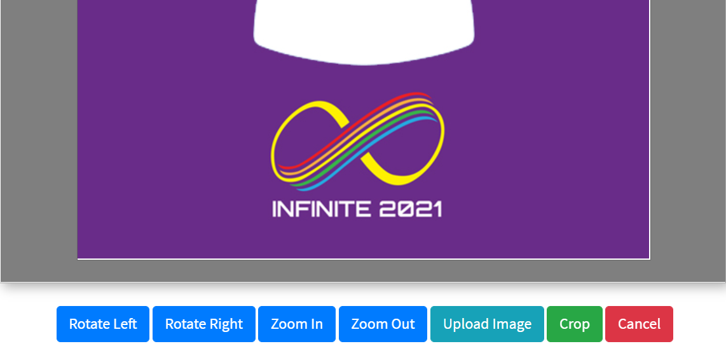

1. You may zoom in/out, and **Click Crop to SAVE** the image
2. **Title:** enter title for the image, if any
3. **Short Description:** enter short description for the image, if any
4. Click “+ Add Image” to insert the second **image (Doesn’t apply to website or youtube project)**

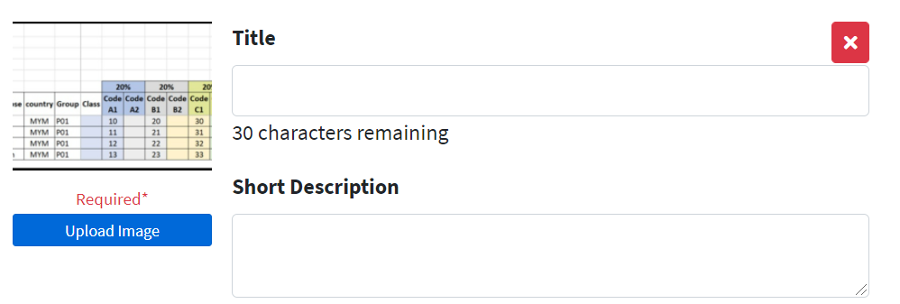

1. Click “X” to delete an image

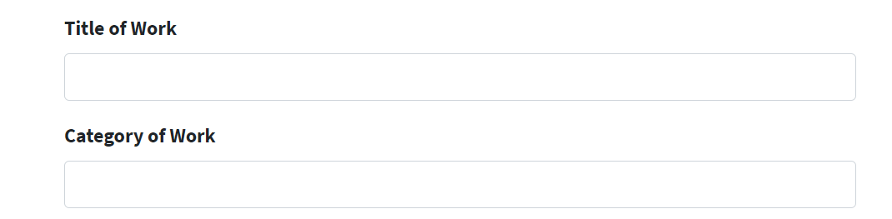

1. **Title of Work:** enter title
2. **Category of Work:** enter category

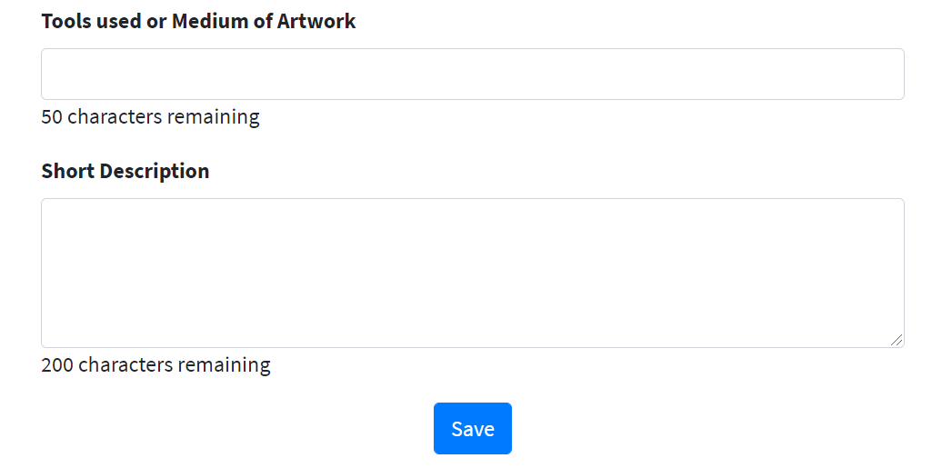

1. **Tools used or Medium of Artwork:** enter tool used or medium of artwork
2. **Short Description:** short description for the project
3. Click “Save” to save the project
4. **External**

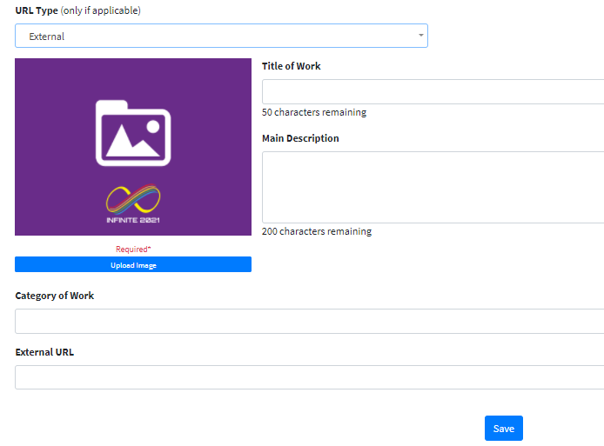

1. **YouTube**

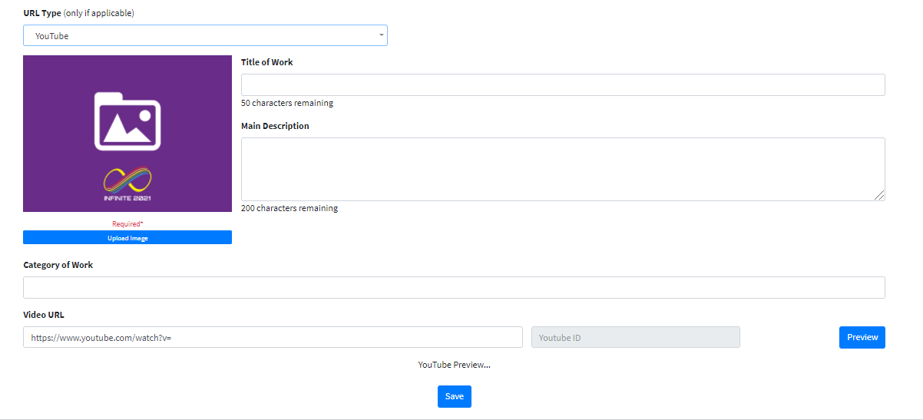

Copy and paste any type of YouTube links under **Video URL** and click **“Preview”**, Youtube video will activate; Click **“Save”** to complete the YouTube project:



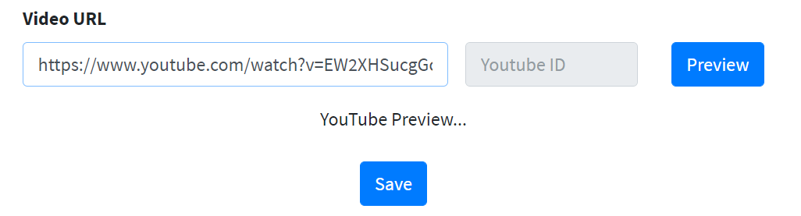

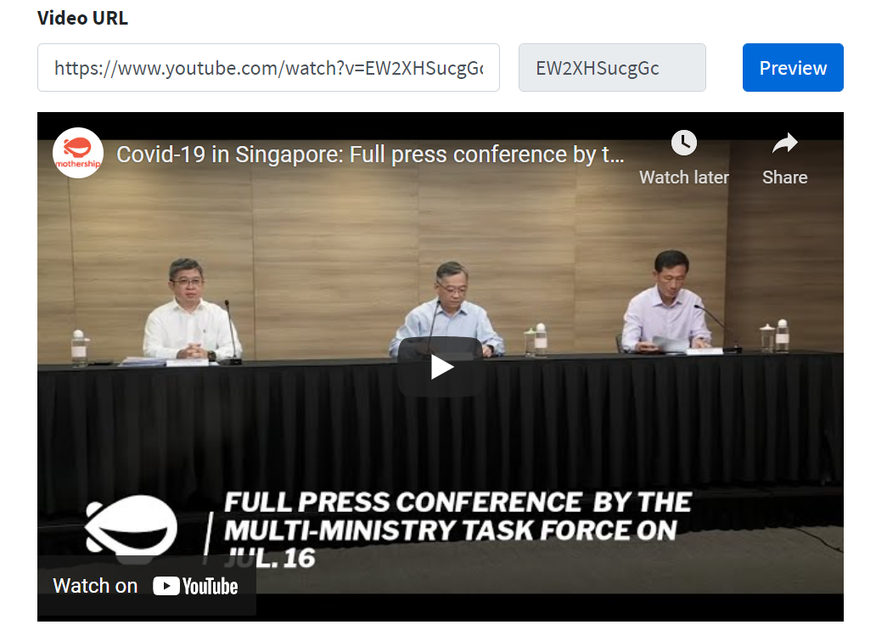

1. **Create an Internship (Available to Year Three Students Only)**

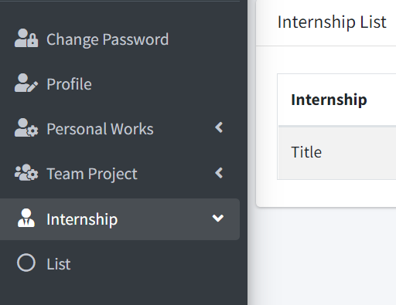

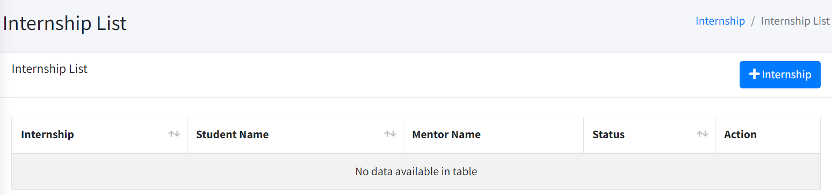

* 1. **Add two mandatory images**

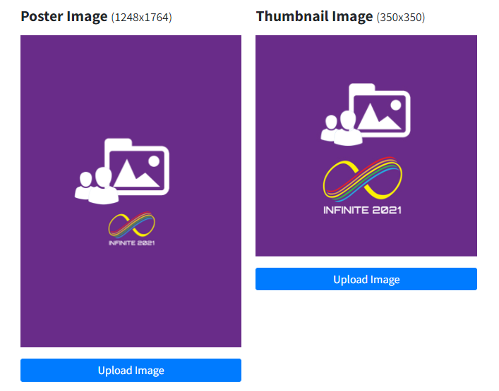

* 1. **Add Title, Description and Save**

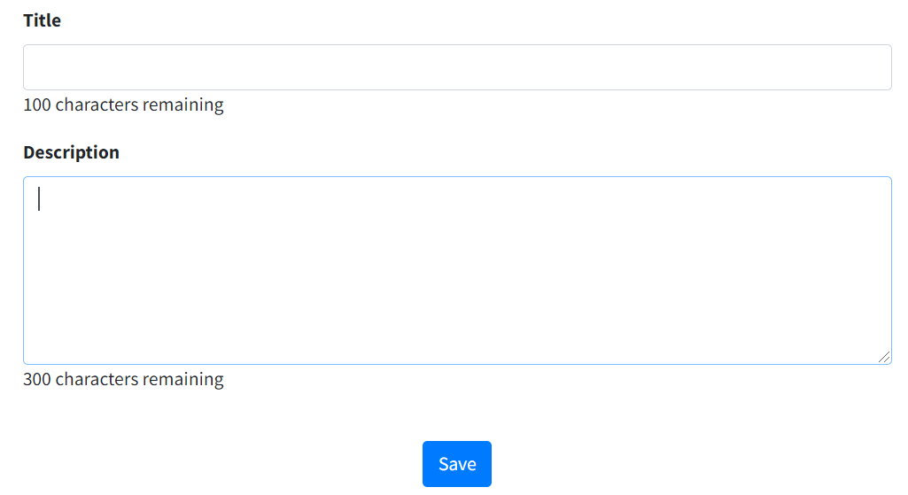

1. **Create a Team Project (Available to Year Three Students Only)**

**NOTE: Only the team leader will create the team project**

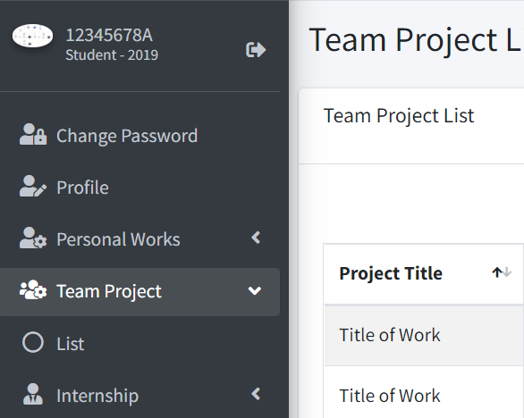

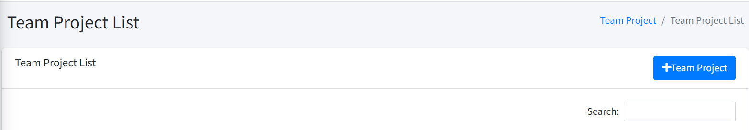

* 1. **Add two mandatory images**

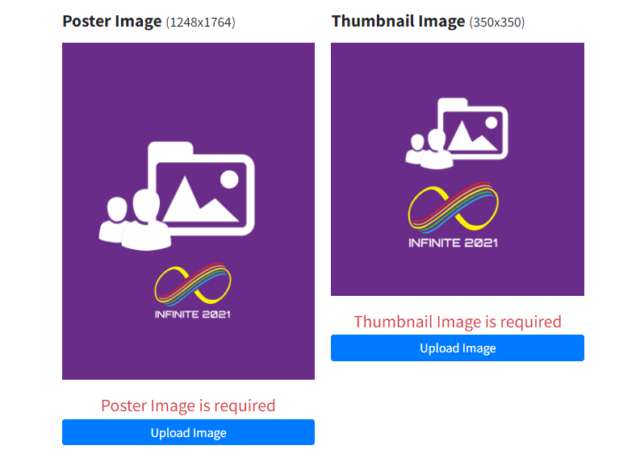

* 1. **Add optional Gallery image, click “+ Add image” to add more images**

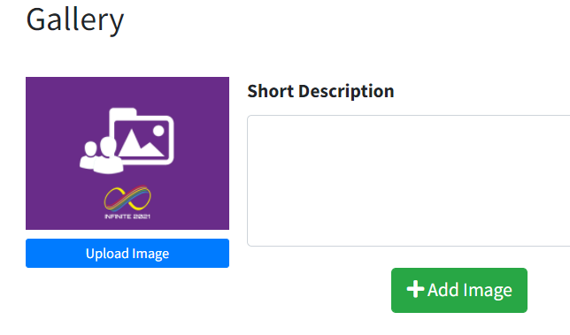

* 1. **Add mandatory Title of Work, Team Name and Nature of project**

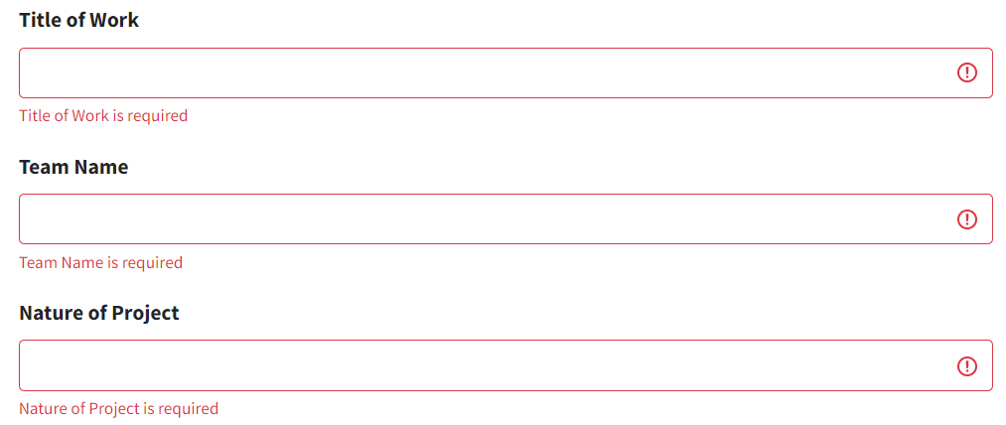

* 1. **Add optional YouTube link, preview it to ensure the link was correct**

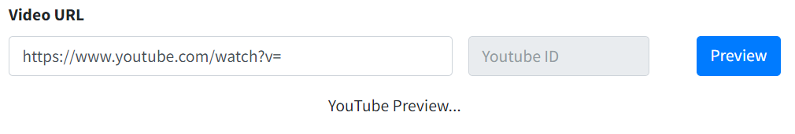

* 1. **Add mandatory Project Description**

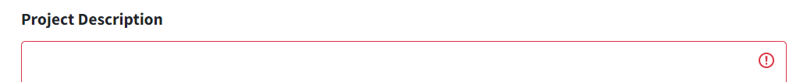

* 1. **Add Role as a Team Leader**

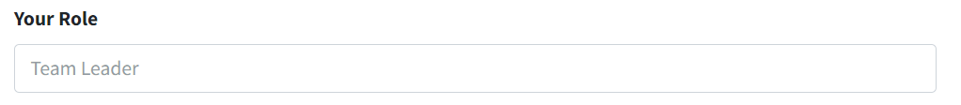

* 1. **Click  to add Member(s)**

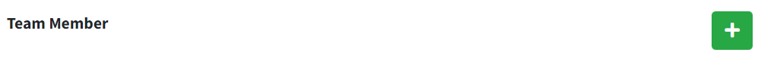

**Type partial name to search for a member, enter the role and job scope**

**Click  to remove a member**

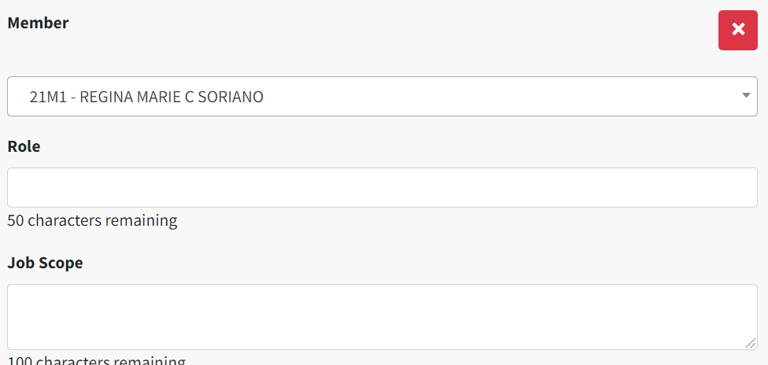

**How to view your profile, personal projects from the eportfolio website (for all staff and students)?**

1. Link: <https://eportfolio.ict.np.edu.sg/cohort/>
2. Select cohort from dropdown list and click “Submit” button

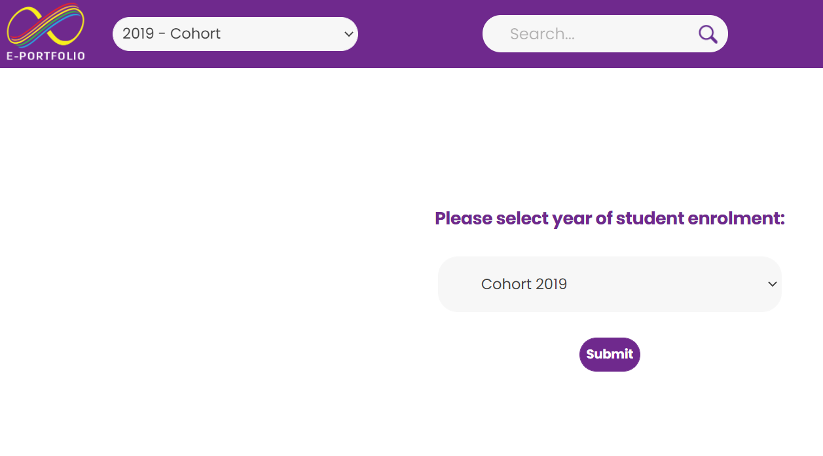

1. Enter your full or partial name or student ID from the “Search” option, and select from the display name

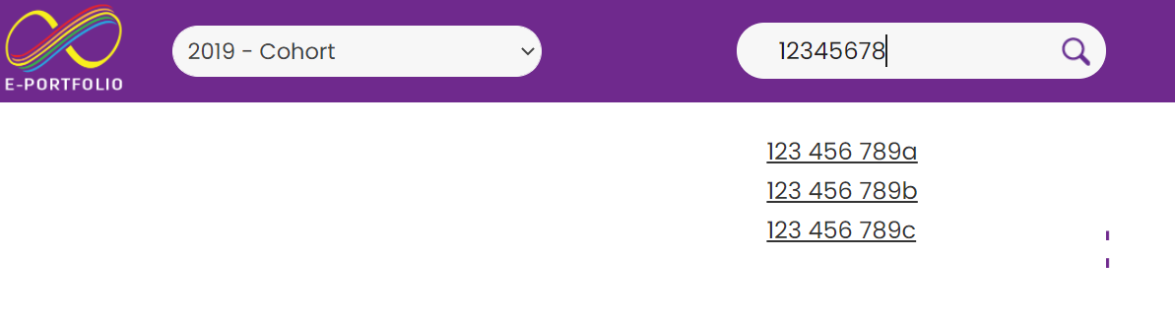

1. Your student profile will display

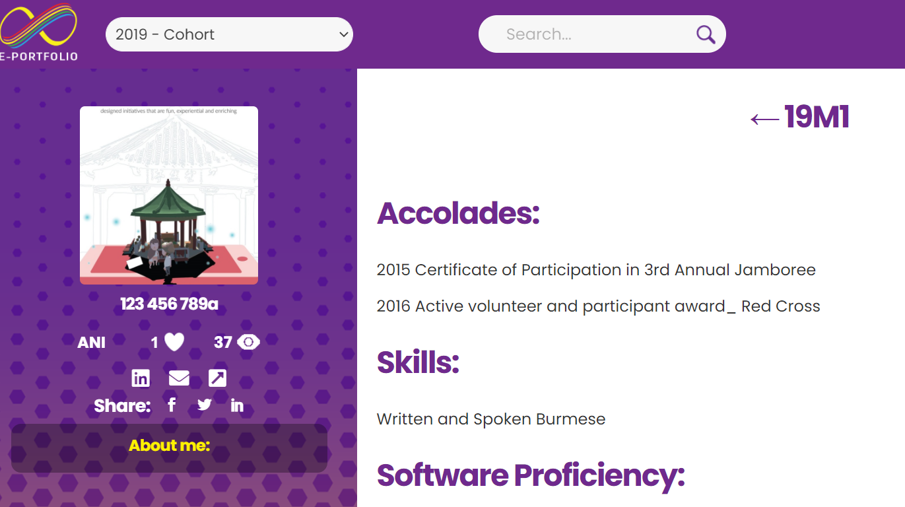

1. To view more than five person projects, **click and hold onto any of the project image**, and **drag the mouse to the left**, to view all projects

**Click and hold, and drag the mouse to the right**, to return to the first image

